EXPERIMENT – 1

Familiarization of environments in R.

R provides an environment for statistical computing, data analysis, graphical representation, and programming. When RStudio is opened, it provides a graphical interface through which we can write and execute R programs.
The major components we need to become familiar with are:
- R Console
- Script Editor / Source Pane
- Environment Pane
- History Pane
- Files Pane
- Plots Pane

1.1: R Console: The Console is where R commands are directly entered and executed. The Console is useful for:
- Executing commands immediately
- Testing small pieces of code
- Performing calculations
- Checking functions
- Viewing output
For larger programs, however, you should generally use the Script Editor.

1.2: Script Editor (Source Pane): The Script Editor is where you write and save R programs.
Create a new R script using: File → New File → R Script
You can also use: Ctrl + Shift + N
Save the file as: <filename>.R
The .R extension indicates an R source-code file.
You can execute individual lines or selected code from the script.
Why use a script? - Unlike typing everything directly into the Console, your code can be: Saved, Edited, Reused, Shared

1.3: Environment Pane: A graphical interface in RStudio that displays the objects currently available in the active R environment, along with information about their names, values, and types.
When you execute:
x < - 1
R creates an object called x.
Now look at the Environment pane.
You should see something similar to:
Environment
x 10
The Environment pane therefore provides a convenient view of the objects currently available in your R session.

1.4: History Pane: The History pane records commands that you have previously executed.
For example, if you run:
x <- 10
y <- 20
x + y
mean(c(10,20,30))
these commands will appear in the History.
This is useful when you:
- Forget a command you previously used
- Want to reuse an earlier command
- Want to inspect your recent work

1.6: Files Pane: The Files pane allows you to browse files and directories from within RStudio.
For example, you might have:
STUR/
│
├── Experiment1.R
├── Experiment2.R
├── data.csv
└── output/
You can navigate through these files directly from RStudio.
This becomes particularly useful when your practicals start involving datasets.

1.7: Plots Pane: The Plots pane displays graphs generated using R.
For example, execute:
x <- c(10, 20, 30, 40, 50)
plot(x)
R will generate a graph, which should appear in the Plots pane.
The Plots pane allows you to view and, depending on the plot, export the generated graph.

1.8: Sample Program

age <- 21.5
cat("Numeric:", age, "\n")
marks <- 85L
cat("Integer:", marks, "\n")
name <- "Abhi"
cat("Character:", name, "\n")
is_student <- TRUE
cat("Logical:", is_student, "\n")
z <- 3 + 2i
cat("Complex:", z, "\n")
numbers <- c(10, 20, 30, 40)
cat("Numeric Vector:", numbers, "\n")
names <- c("Abhi", "Rahul", "Aman")
cat("Character Vector:", names, "\n")

Output:
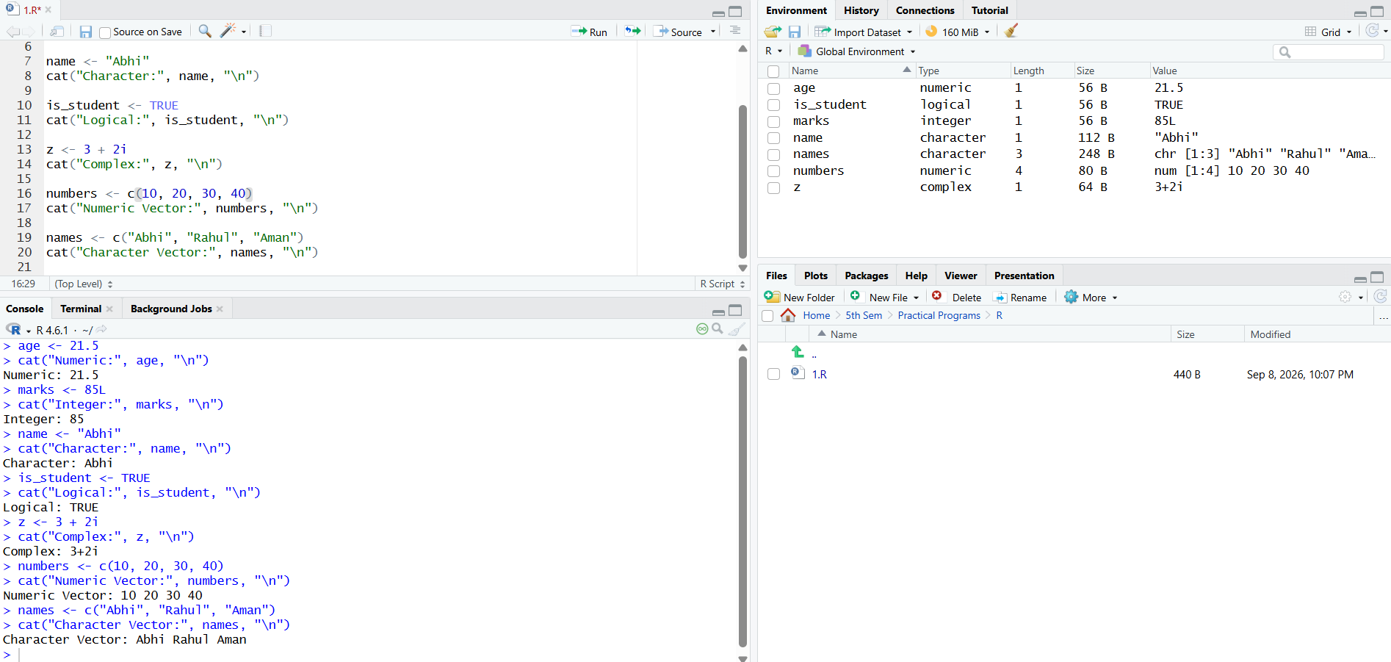

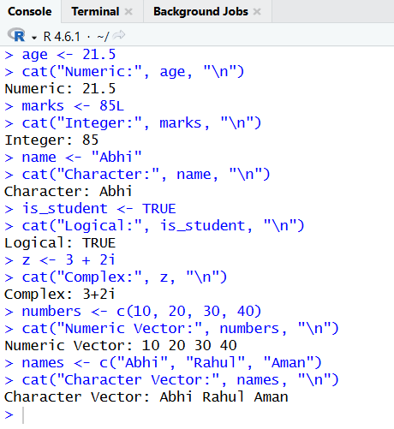

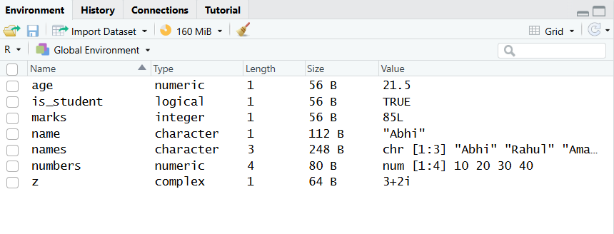

EXPERIMENT – 2

Perform simple arithmetic’s using R.

Code:
a <- 20
b <- 5

print("Addition:")
print(a + b)

print("Subtraction:")
print(a - b)

print("Multiplication:")
print(a * b)

print("Division:")
print(a / b)

print("Modulus:")
print(a %% b)

print("Integer Division:")
print(a %/% b)

print("Power:")
print(a ^ b)

Output:
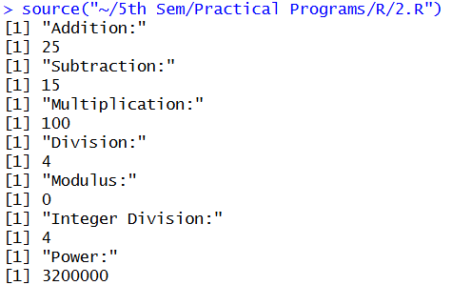

EXPERIMENT – 3

Perform basic R functions.
Code:
numbers <- c(10, 20, 30, 40, 50)

# Basic mathematical functions
cat("Sum:", sum(numbers), "\n")
cat("Mean:", mean(numbers), "\n")
cat("Minimum:", min(numbers), "\n")
cat("Maximum:", max(numbers), "\n")
cat("Range:", range(numbers), "\n")
cat("Length:", length(numbers), "\n")

# Mathematical functions
cat("Absolute value:", abs(-25), "\n")
cat("Square root:", sqrt(25), "\n")
cat("Round:", round(12.5678, 2), "\n")
cat("Ceiling:", ceiling(12.3), "\n")
cat("Floor:", floor(12.8), "\n")

# Statistical functions
cat("Median:", median(numbers), "\n")
cat("Standard deviation:", sd(numbers), "\n")
cat("Variance:", var(numbers), "\n")

# Sorting functions
cat("Sorted values:", sort(numbers), "\n")
cat("Reverse sorted values:", sort(numbers, decreasing = TRUE), "\n")

# Sequence function
cat("Sequence:", seq(1, 10, by = 2), "\n")

# Repetition function
cat("Repeat:", rep(5, 4), "\n")

# Type checking functions
x <- 10
cat("Is numeric:", is.numeric(x), "\n")
cat("Is character:", is.character(x), "\n")
cat("Is integer:", is.integer(x), "\n")

# Conversion functions
y <- "100"
cat("Character to numeric:", as.numeric(y), "\n")

# Other useful functions
cat("Class:", class(numbers), "\n")
cat("Number of elements:", length(numbers), "\n")
Output:
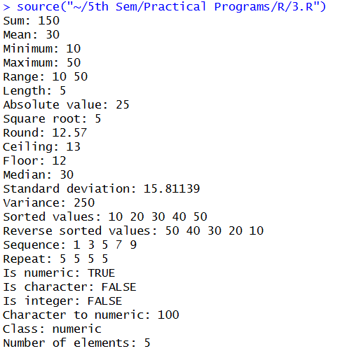

EXPERIMENT – 4

Use various graphical techniques in EDA.
Code:
# Create sample data
students <- data.frame(
Name = c("Abhi", "Saurav", "Mahira", "Shyam", "Shweta", "Akash", "Ibrahim", "Pritam"),
Marks = c(85, 75, 90, 65, 80, 87, 23, 45),
Hours = c(5, 3, 6, 2, 4, 3, 1, 2)
)
print(students)

# 1. Histogram
hist(
students$Marks,
main = "Histogram of Marks",
xlab = "Marks"
)

# 2. Boxplot
boxplot(
students$Marks,
main = "Boxplot of Marks",
ylab = "Marks"
)

# 3. Bar Plot
barplot(
students$Marks,
names.arg = students$Name,
main = "Marks of Students",
xlab = "Students",
ylab = "Marks"
)

# 4. Pie Chart
pie(students$Marks,
labels = students$Name,
main = "Marks Distribution"
)

# 5. Scatter Plot
plot(
students$Hours,
students$Marks,
main = "Study Hours vs Marks",
xlab = "Study Hours",
ylab = "Marks"
)

# 6. Line Plot
plot(
students$Marks,
type = "o",
main = "Marks Trend",
xlab = "Student",
ylab = "Marks"
)

Output:
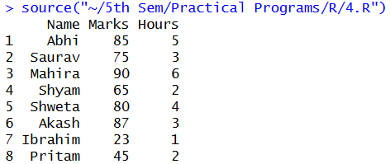

Plots Obtained:

EXPERIMENT – 5

Create different charts for visualization of given set of data.

Code:
# Load the built-in dataset
data(mtcars)

# Display the dataset
print(head(mtcars))

# 1. Bar Chart - Number of Cars by Cylinders
cylinder_count <- table(mtcars$cyl)

barplot(
cylinder_count,
names.arg = names(cylinder_count),
main = "Cars by Number of Cylinders",
xlab = "Number of Cylinders",
ylab = "Number of Cars"
)

# 2. Histogram - Miles per Gallon
hist(
mtcars$mpg,
main = "Distribution of MPG",
xlab = "Miles per Gallon",
ylab = "Frequency"
)

# 3. Boxplot - MPG
boxplot(
mtcars$mpg,
main = "Boxplot of MPG",
ylab = "Miles per Gallon"
)

# 4. Scatter Plot - MPG vs Weight
plot(
mtcars$wt,
mtcars$mpg,
main = "MPG vs Weight",
xlab = "Weight",
ylab = "Miles per Gallon",
pch = 19
)

# 5. Pie Chart - Transmission Type
pie(
table(mtcars$am),
labels = c("Automatic", "Manual"),
main = "Transmission Types"
)

# 6. Line Chart - MPG of Cars
plot(
mtcars$mpg,
type = "o",
main = "MPG of Cars",
xlab = "Car Number",
ylab = "Miles per Gallon"
)
Output:
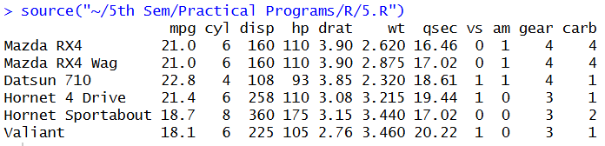

Plots Obtained:

EXPERIMENT – 6

Find the mean, median, standard deviation and quartiles of a set of observations.

Code:
x <- c(10, 80, 93, 56, 36, 6, 93, 72, 62, 43)

mean_value <- mean(x)
median_value <- median(x)
sd_value <- sd(x)
quartiles <- quantile(x)

cat("Given set of observations:", x, "\n\n")

cat("Number of Observations: ", length(x), "\n")
cat("Mean: ", mean(x), "\n")
cat("Median: ", median(x), "\n")
cat("Standard Deviation: ", sd(x), "\n")
cat("Quartiles:\n")
print(quartiles)

Output:
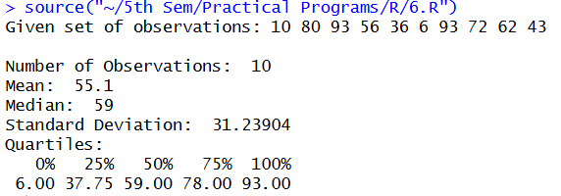

EXPERIMENT – 7

Find the Skewness and Kurtosis of a given dataset distribution.

Code:
library(moments)

data(iris)
cat("6 TOPMOST ROWS OF DATASET:\n")
print(head(iris))

skewness_values <- apply(iris[, 1:4], 2, skewness)
kurtosis_values <- apply(iris[, 1:4], 2, kurtosis)
cat("\nSKEWNESS VALUES OF ALL NUMERIC COLUMNS:\n")
print(skewness_values)
cat("\nKURTOSIS VALUES OF ALL NUMERIC COLUMNS:\n")
print(kurtosis_values)

hist(
iris$Sepal.Length,
main = "Distribution of Sepal Length with KDE",
xlab = "Sepal Length",
ylab = "Density",
breaks = 20,
border = "darkgreen",
col = "lightgreen",
ylim = c(0, 0.6),
xlim = c(4, 8),
freq = FALSE
)

kde_Sepal.Length <- density(iris$Sepal.Length)

lines(
kde_Sepal.Length,
col = "red",
lwd = 2
)

hist(
iris$Sepal.Width,
main = "Distribution of Sepal Width with KDE",
xlab = "Sepal Width",
ylab = "Density",
breaks = 20,
border = "darkgreen",
col = "lightgreen",
ylim = c(0, 1.9),
xlim = c(2, 4.5),
freq = FALSE
)

kde_Sepal.Width <- density(iris$Sepal.Width)

lines(
kde_Sepal.Width,
col = "red",
lwd = 2
)

hist(
iris$Petal.Length,
main = "Distribution of Petal Length with KDE",
xlab = "Petal length",
ylab = "Density",
breaks = 20,
border = "darkgreen",
col = "lightgreen",
ylim = c(0, 0.6),
xlim = c(1, 6.9),
freq = FALSE
)

kde_Petal.Length <- density(iris$Petal.Length)

lines(
kde_Petal.Length,
col = "red",
lwd = 2
)

hist(
iris$Petal.Width,
main = "Distribution of Petal Width with KDE",
xlab = "Petal Width",
ylab = "Density",
breaks = 20,
border = "darkgreen",
col = "lightgreen",
ylim = c(0, 2.4),
xlim = c(0.1, 2.6),
freq = FALSE
)

kde_Petal_Width <- density(iris$Petal.Width)
lines(
kde_Petal_Width,
col = "red",
lwd = 2
)
Output:
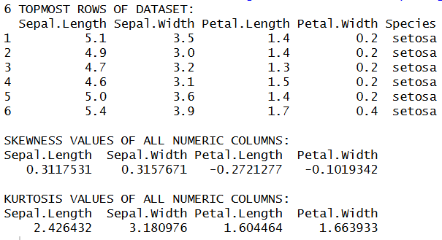

Plots Obtained:

EXPERIMENT – 8
Given the scenario, implement the Bayes rule by finding the posterior probability.

Code:

